# Pak-Austria Fachhochschule Institute of Applied Sciences and Technology, Haripur

**LAB 02 – Spring 2025**

|  |  |  |  |
| --- | --- | --- | --- |
| Name: | Inshirah Hassan | Reg NO.: | B22F0064SE112 |
| Subject: | Software Development and Construction | Instructor: | Dr. Nabeel Ahmed_________ |
| Time Allowed: | 2 hr 30 min. | Lab Engineer: | Zainab Tahir |

1. Write a Java program that checks if a number is even or odd using an **if** statement. Print "**Even**" if the number is even and "**Odd"** if the number is odd.

**Code:**

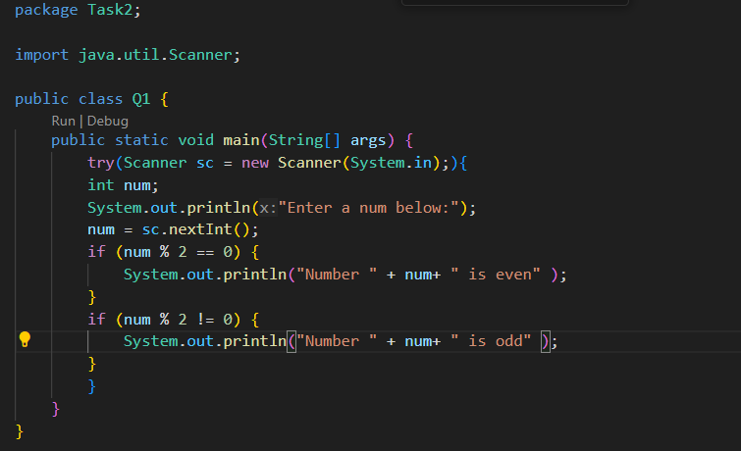

**Output:**

1. Create a Java program that checks if a person is eligible to vote. The eligibility is determined if the person’s age is **18** or older. Use an if-else statement to print "**Eligible to vote**" if the person is 18 or older, and "**Not eligible to vote**" otherwise

**Output:**

1. Write a Java program that determines the grade of a student based on a score. Use else-if to print "**A" for scores** **90** and a**bove**, "**B" for scores 80-89,** "**C" for scores 70-79**, "**D" for scores 60-69**, and "**F**" **for scores below 60.**

**Output:**

1. Write a Java program that simulates a traffic light system. The program should use a switch statement to print the action to take based on the current traffic light color. The traffic light colors are represented by integers as follows:

* 1 for Red
* 2 for Yellow
* 3 for Green

The program should print the following actions:

* **Red**: "Stop"
* **Yellow**: "Get Ready"
* **Green**: "Go"

**Output:**

1. Develop a Java program that prints the name of the month based on the month number (1-12) using a switch statement. For example, if the month number is 3, it should print "March".

**Output:**

1. Create a Java program that calculates the sum of all even numbers from 1 to 50 using a while loop. Print the total sum after the loop finishes

**Output:**

1. **A computer screen shot of a computer code

   Description automatically generated**Write a do-while loop that calculates the sum of all positive integers entered by the user. The loop should terminate when the user enters a negative number.

**Output:**

